Press Release

Unique Book Details a Mother-Daughter End of Life
Sojourn with Humor, Honesty and Wisdom

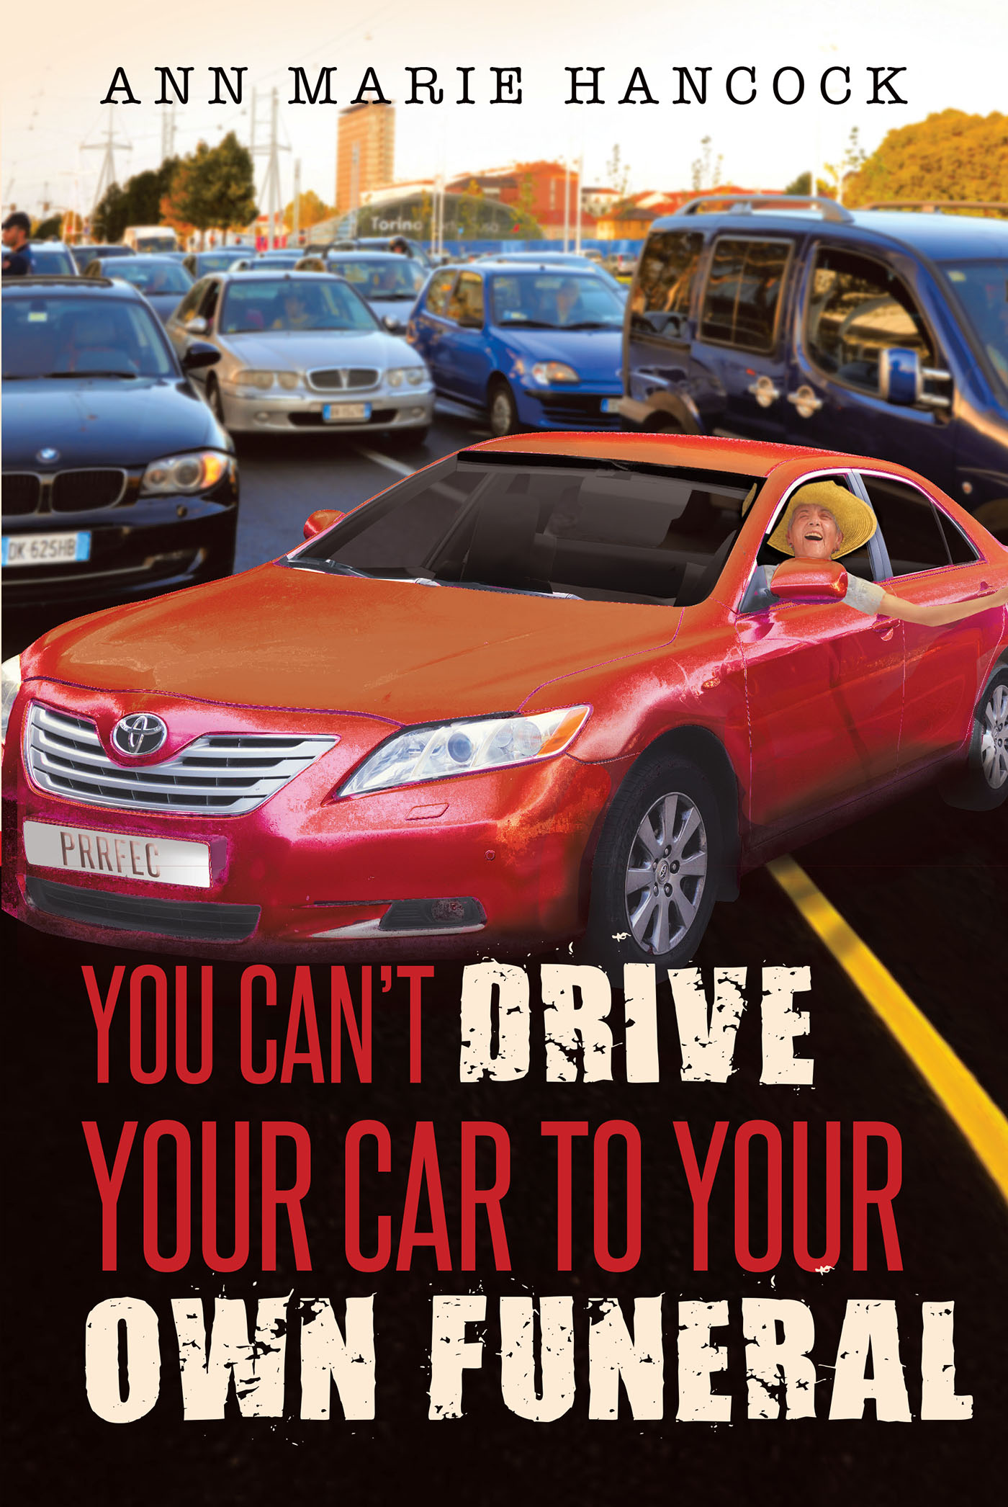
“A truly exceptional…read.”
- John J. Kelly, Detroit Free Press

Richmond, VA -- Aptly titled after her onerous mother’s escapades, You Can’t Drive Your Car to Your Own Funeral is an honest and unique book that looks at the challenges of guardianship and cancer. Written with deep spiritual insight that can only be cultivated through adversity, and tempered with humor, this book traverses the difficult passage of end-of-life caregiving and the challenges and joys that accompany it.

“Ann Marie Hancock has gifted the world with a memorable book…a wise, warm and at times humorous message about living life to the fullest.”
– Dr. Grady Harp, Amazon Top 50 Book Reviewer

“I wrote You Can’t Drive Your Car to Your Own Funeral with complete dedication, commitment, and the hope that you will find loving solutions to the stressful challenges of caring for a “difficult” dear one. This is my story, but yours as well. We all have a difficult person in our lives,” says author Anne Marie Hancock.
It was no easy task. Her mother, in her 90s and denying the existence of her cancer, refused to give up her car or her independence, and lived alone until the end. Hancock remembers one day when her mother insisted on driving them to an appointment. She ran through two red lights. When Hancock said something, her mom replied, “Don’t worry about it. You dad did it all the time.”
Hancock is no stranger to tragedy. She and her husband lost their second child shortly after birth from hyaline membrane disease. Her older daughter has Multiple Sclerosis. And Hancock herself faced death on her 50th birthday when her heart stopped and she had to be revived. When her mother was diagnosed with cancer, Hancock kept a journal for three-years with reflections on her sojourn. The journal evolved into book form because Hancock wanted to share the vital and unanticipated lessons she learned.
“It was Ann Marie’s belief in God which was her strength, and this enabled this wound healer to face her greatest challenge yet.” – Susan Keefe, Midwest Book Review
Hancock retired from a prolific career as talk show host of various documentaries and television programs, where she met the likes of Aba Eban, Alan Alda, Eva Gabor, Michael Landon, the Dalai Lama, Mary Higgins Clark, John Belushi, Minnie Pearl and many more. She broke the glass ceiling at WRVA Radio in 1965 while a student at the University of Richmond, as the station’s first female news reporter.

She had a reputation as a hard-nosed journalist, always after facts and credible sources, always asking the difficult questions, so it was with some astonishment that she heard about the Marian Apparitions in Medjugorje, Yugoslavia. She traveled there, spending a week questioning the “miracles”. The scientific studies on the visionaries were incredible, but well documented. What she discovered, changed her life.

Ann Marie has traveled the world speaking about the power of God’s healing love. She was encouraged by Og Mandino, whom she met in her television days. She was interviewed for Heavens’ Touch, a healing documentary for PAX television.
“My consistent message is there is One God; he did not divide us; we divided ourselves. We are all made in his image and likeness; we are all miracles.”
But her book is down-to-earth and sheds light on the universal situation of caregiving. It demonstrates what the human soul is capable of enduring, as seen by one who has experienced much tragedy. “We’re capable of emerging from these situations more balanced, stronger and more loving,” says Hancock.
Her mother, who never accepted her cancer diagnoses, is now gone. Hancock gave up three years of her life to care for her, and says the result is she now feels blessed. There is no guilt, and she knows she did the best she could for her mom.
“This book is a ‘from the heart’ blooming of love and faith – an end-of-the-tunnel light for all of us.” – Dr. Grady Harp, Amazon Top 50 Book Reviewer
The spiritual memoir is also chock full of practical advice, to help you and your loved navigate the end-of-life duties that come your way.

“This is a most hopeful and optimistic book about how we must strive to care for the ones we love, even when it hurts.” – John J. Kelly, Detroit Free Press

“God is not expecting us to be perfect, but to do our best,” says Hancock. “We have an intellect and a free will. We have the opportunity every day to choose love and to see through eyes of beautify rather than darkness.”

--END—

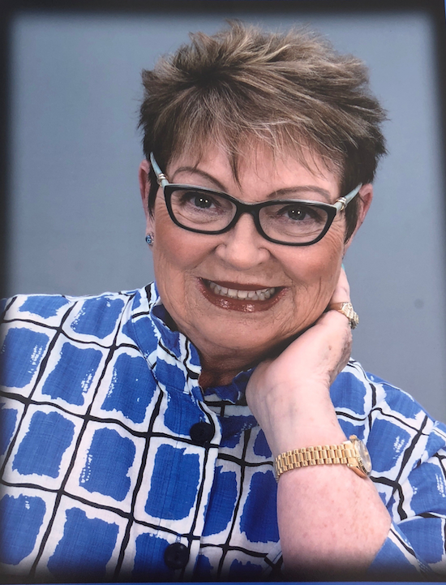
About Ann Marie Hancock: Ann Marie Hancock is an award-winning journalist, radio personality and talk show host who has interviewed many famous people. She has appeared on Bertice Berry, Rolanda, NBC’s The Other Side, The Angel Show and Inside Edition.

Hancock is the author of two previous books: Be A Light and Wake Up America. Her latest book, “You Can’t Drive Your Car to Your Own Funeral, is based on the three-year journey of caring for her terminal mother and the spiritual as well as practical lessons she learned along the way.

She has an extensive background in volunteerism: she served on the Parents Council of The Virginia Military Institute; she co-chaired the State Catholic Concilium on Education, served on the Boards of Virginia Goodwill Industries; Pediatric Infusion, the James River Association, the Virginia Wildlife Festival, has worked extensively with the Make a Wish Foundation, and hosted the first Miss Virginia Wheelchair Pageant. She has been honored by The Virginia Rehabilitation Association and received The Breath of Life Award from The American Red Cross.

Ann Marie Hancock lives in Virginia with her husband Tom, a retired nationally recognized attorney in health and hospital law, consistently listed in Best Lawyers in America.

You Can’t Drive Your Car to Your Own Funeral, ISBN 978-1641386432, 2018, Page Publishing, Inc, paperback, $16.95, hardcover, $24.95, ebook: $9.99 106 pages, available on Amazon.

Media Contact: For a review copy of You Can’t Drive Your Car to Your Own Funeral or to arrange an interview with Anne Marie Hancock, contact Scott Lorenz of Westwind Communications Book Marketing at scottlorenz@westwindcos.com or by phone at 734-667-2090. Follow Lorenz on twitter @abookpublicist

